**TikTok Camp - Group 16’s Project Report:**

**Assignment B: Android Development Group Project**

By Tan Ming Zhe, Lee Ching Jet Terry, Yong Zi Ren, Maizurah Begum, Shamir, Ching Teng

Technical Overview

One key technical selection that we have used is Firebase, which was not taught in the lessons. As we wanted our application to have an authentication tool, we decided to go with Firebase Authentication, which we found as the most effective method to do so. Some examples of us using Firebase Authentication

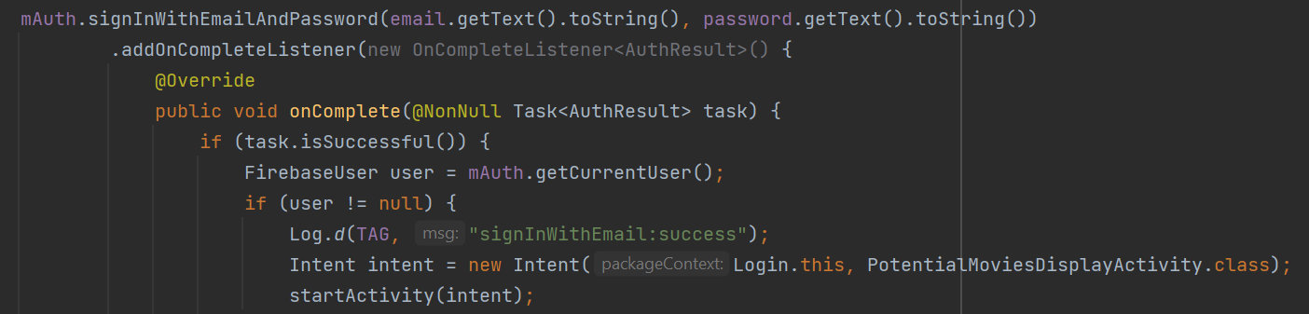

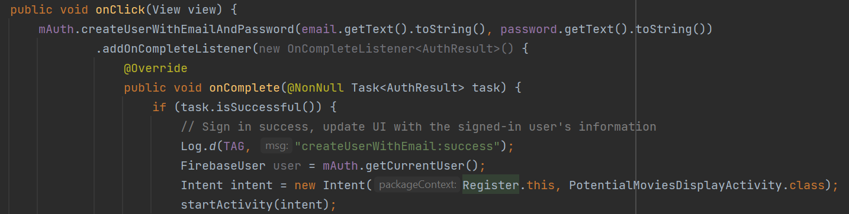

Another key technical selection would be how we have shown the movies on the movies display page. The data was obtained from the OMDB API, which we then populated into 3 different Recycleviews under Suggested, Trending and Last Seen.

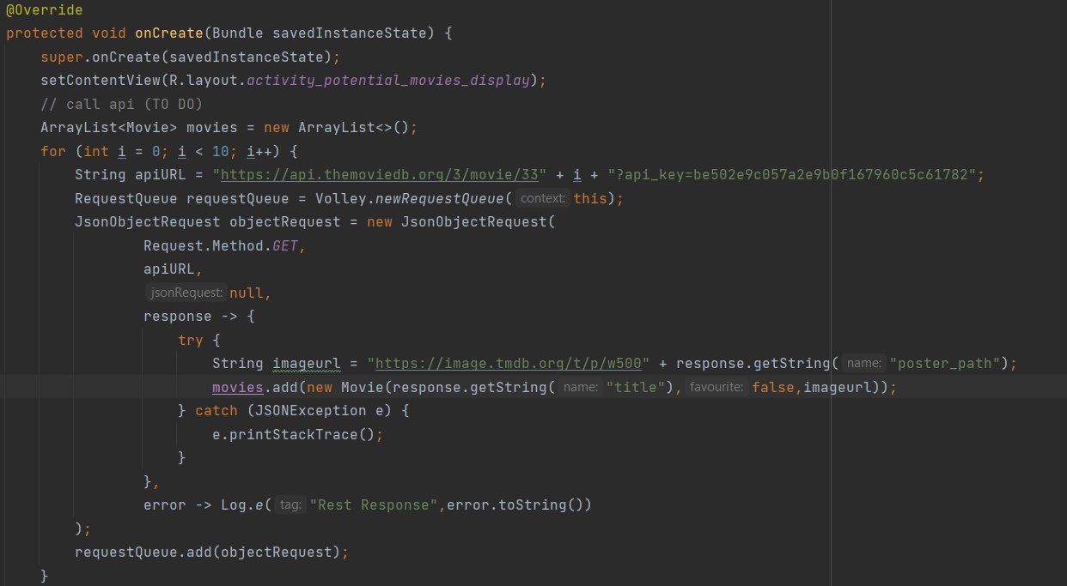

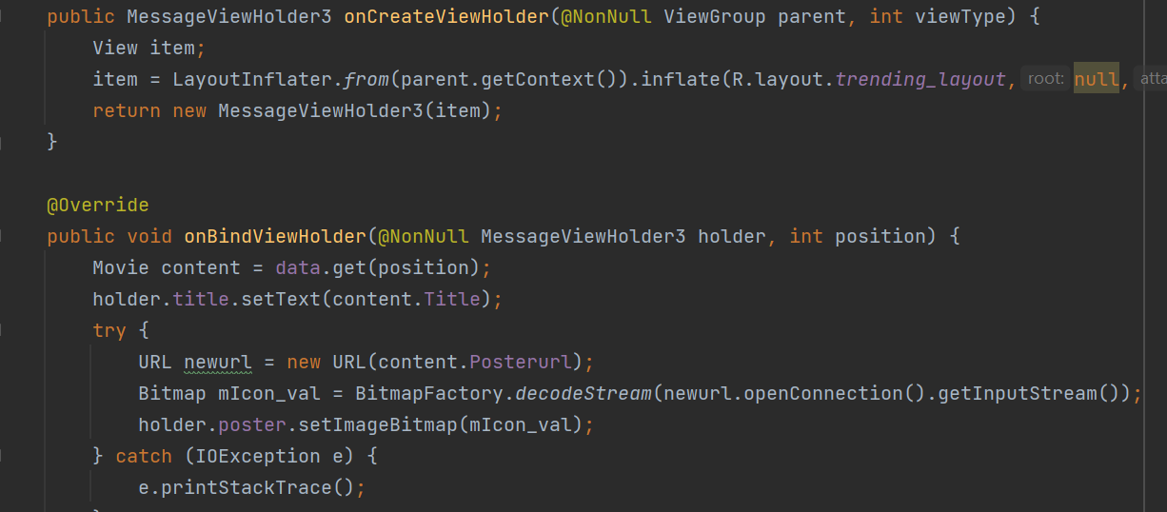

Product Overview

Introducing the new 'TikMovie', an Android application that can be used to search for movies. Users can create an account, or login with an existing account. After logging in, they can then use the application to search for movies and to also keep track of what they’ve watched. There is also a rating system, where users can rate movies out of 5 stars, ‘favourite’ movies they like and also get recommendations based on what they have watched. The application has various features including a register page, login page, display movies, search and a favourite movie and the search.

The following screenshots are from our Figma project.

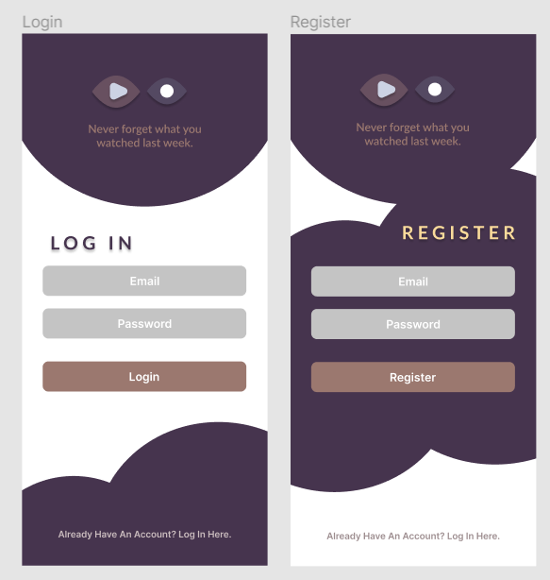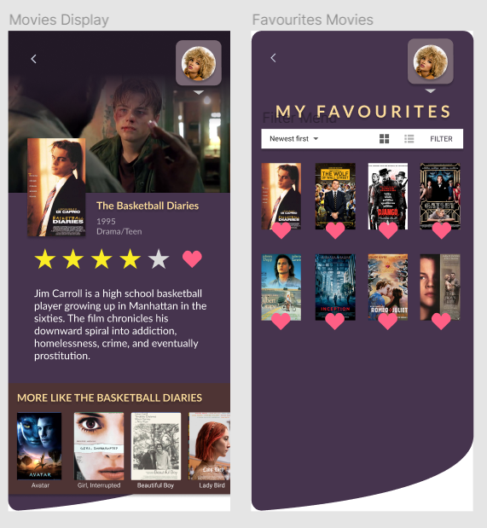

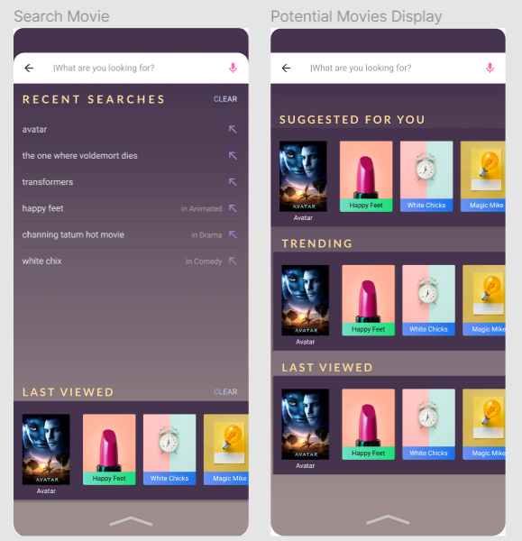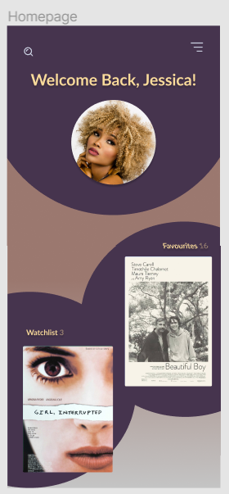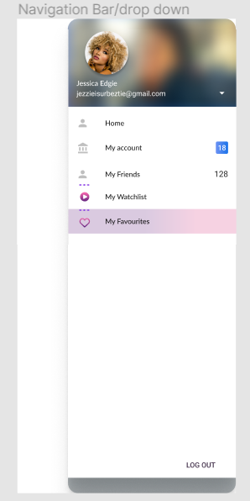

Favourite page:

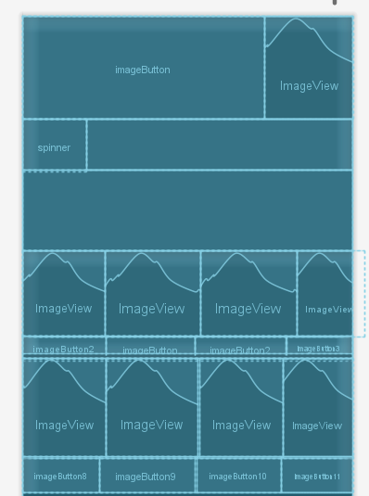

Login page:

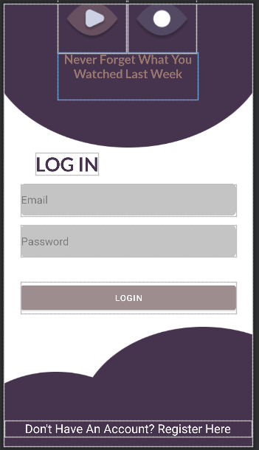

Register Page:

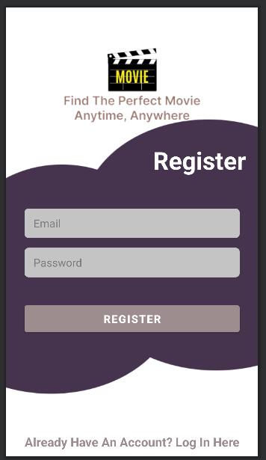

Display Page:

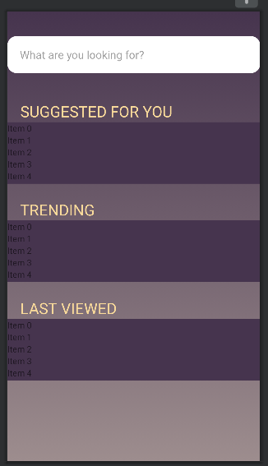

Highlights

The most interesting part of the application would be the Movies Display page, which is for users to see their display activity. As there are 3 different features in the movie display page - the Suggested, Trending and Last Seen, each of them needed to have its own Message Adapter as well as its own MessageViewHolder code.

The code first calls the API from the theMovieDB to get the data of the movies as well as the images. If there is an error in doing so, the application will inform the user with a “Rest Response”. After obtaining the data, the application will then use RecyclerView and populate it with the data obtained for each feature. Each of the RecyclerView is meant for each feature.

The User Interface for the Movie Display page:

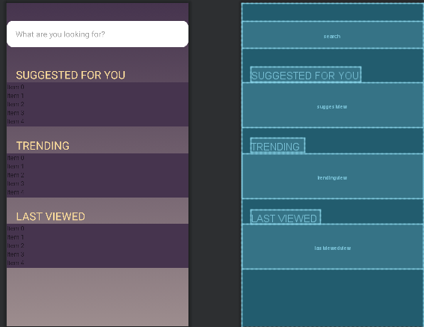

Project Management

Our project is split into two teams - the User Interface team, who is in charge of designing a user friendly and appealing interface, and the Coding team, who is tasked to research and code on how certain features should work.

The user interface work distribution are as follows:

Movie Display Page, Favourite Movie Page, Search Movie display, Homepage and Navigation Bar - Maizurah

Login Page and Register Page - Terry

The user interface team consisting of Maizurah and Terry mainly used Figma to create the prototype interfaces. The team went through constant edits to improve the pages, starting out with a basic layout before adding assets and pictures and looking at existing pages to see what kind of user interfaces is the most suitable.

The link to our Figma: <https://www.figma.com/file/fcWqzStSQekTdam3zaSjyr/TikMovie?node-id=5%3A3>

The Coding Team:

Each member in the coding team is assigned to research and code on one feature of the application. The features split between the members are the login page, the register page, the search bar, the favourite page and the main movie page.

The technical work distribution are as follows:

Register Page - Ming Zhe

Login Page - Terry

Display Page - Zi Ren

Favourite Movie Page - Ching Teng

Search Function - Shamir

The link to Github:

<https://github.com/tgonet/TikMovie>